Contents

Web Accessibility 2

Website Colour Theory & Psychology 2

Commercial Drone Specification 3

Legal Issues of Drone Ownership & Use 4

Commercial Drone Technology 5

Police & Fire 5

Agriculture 6

Business & Companies 6

Racing 6

Filming, Cinematography & Photography 7

Commercial Drones in Education 7

Further Education (FE): 7

Higher Education (HE): 7

Website Testing in Multiple Browsers 8

Google Chrome: 8

Mozilla Firefox: 8

Microsoft Edge: 9

Web Based Image Editing 10

HTML Validation 11

CSS Validation 14

Web Accessibility Validation 15

High Contrast Print Style Sheets 16

References 18

Appendices 20

The following document provides evidence of my research in both written and screenshot forms.

# Web Accessibility

Web accessibility means that users with disabilities can still access and navigate the web, despite their impairments. Such disabilities include visual, auditory, physical, speech, cognitive and neurological. Although, depending on the severity, these disabilities can make it very difficult for people to access and interact with the web. Procedures can be put into place in order to make your website as accessible as possible by users that suffer from these disabilities. It is important to consider web accessibility as the web is becoming an increasingly important resource in many aspects of life. Such as; education; employment; government; commerce; health-care and many more. It is therefore important to provide equal access and opportunity to people with disabilities. (Henry & Dick, 2005)

There are a set of guidelines that have been put into place that must be adhered to in order to make your website accessible. These guidelines are called WCAG 2.0 (Web Content Accessibility Guidelines 2.0). They state that the website in question should be perceivable, operable, understandable and robust. For example, there should be text alternatives for non-text content, or captions for multimedia. All functionality should be available from the keyboard and help should be provided to help users navigate content. Text should be readable and understandable and compatibility should be maximised with current and future user tools. (Henry & Dick, 2011)

There is also a ‘conformance logo’ created by [W3C](https://www.w3.org/) that you can display on your website to show that it conforms to the WCAG guidelines and further promotes web accessibility. There are three levels of conformance. Level A, AA and AAA. These refers to 3 sets of criteria that can be found [here](https://www.w3.org/WAI/WCAG2-Conformance.html#level-A). By displaying this logo on your site you are helping raise awareness of accessibility issues on the web. (Anon., n.d.)

# Website Colour Theory & Psychology

The ability to manipulate colours is considered an art form by both master painters and web designers. This art form is applicable in lots of modern commercial and business industries. Three important attributes to consider are; contrast; complementation and vibrancy.

Contrast is important as every shade of colour has an opposite or a ‘competitor’ if you will. This means that you should really try and avoid using these colours together as they tend to produce an un-appealing image. The greater the contrast, the less appealing they look. It is therefore important to choose colours that blend well together and don’t contrast each other that much. Please see Appendix 1, the colour wheel, to see which colours contrast each other. Simply locate the colour on the opposite end of the circle. The colour wheel lists the shades of colours in the order of wavelengths of light on the visible light portion of the electro-magnetic spectrum. This is the order ROYGBIV (Red, Orange, Yellow, Green, Blue, Indigo, Violet).

Complementation is when two colours literally ‘complement’ one another. This is when the two are relatively close on the colour wheel. For example, purples complement is green. When used correctly together on a website or any design, it provides an aesthetically pleasing image and is quite easy on the eye.

Vibrancy of colours refers to the mood that a particular colour conveys, For example, the brighter, warmer colours such as red, orange and yellow tend to produce a warm, energising feeling. However, darker, cooler shades such as green, blue and purple tend to be more relaxing and tranquil. Depending on the type of website that you are designing, it is therefore important that you pick the right vibrancy of colours to ensure the user is in the right mood.

Here are some further examples of what specific colours convey;

* **Red:** Power, Importance, Youth.
* **Orange:** Friendliness, Energy, Uniqueness.
* **Yellow:** Happiness, Enthusiasm, Antiquity.
* **Green:** Growth, Stability, Financial Themes, Environmental.
* **Blue:** Calm, Safety, Openness, Reliability, Serenity.
* **Purple:** Luxury, Romance, Mystery.
* **Black:** Power, Edginess, Sophistication.
* **White:** Cleanliness, Virtue, Simplicity.
* **Grey:** Neutrality, Formality, Melancholy.
* **Beige:** Traits of surrounding colours.
* **Ivory:** Comfort, Elegance, Simplicity.

(Cao, 2015)

# Commercial Drone Specification

When looking to purchase a drone, it is important to consider the variety of specifications and how they affect the product you buy. Depending on the uses you have for the drone, there are some specifications you will need, and some you won’t. Here are some you should look out for;

* **Max Flight Time:** The maximum flight time refers to the battery life of the drone. Depending on what you are using your drone for, you may need to pay the extra for a long lasting battery. However, if you do not need to fly your drone for long periods of time, you can save money and buy a cheaper battery.
* **Operating Range:** The operating range is the distance, in meters, that the drone can be remotely operated from. For example, if the operating range is 80m, you need to be within 80m of the drone in order to control it. If you are filming on a remote location like a mountain top, you would need a large operating range to ensure you don’t lose your drone.
* **Wingspan:** The wingspan is the total linear distance from the edges of the outermost wings, measure in mm. This is important to consider if you are going to be piloting you drone outdoors in windy locations. A larger wingspan will provide greater stability when flying you drone in windy conditions.
* **Applications:** Some drones are suited to different types of flying. The drone’s description may list one of the following applications. Agriculture, Film & Photography, Mapping, Surveying.
* **Control System Type:** This refers to the device that you will remotely control your drone from. Some drones come with their own remote control, other can be controlled from an app on a smartphone/tablet, and some allow both.
* **Weight:** Quite self-explanatory, the weight of the drone is how much the drone weighs when fully equipped, in grams. This is important to consider as you may need your drone to be very nimble and agile for quick movement and camera shots. Also, if flying outdoor, a very light drone may get caught in the wind easily and cause your shots to be distorted.
* **Maximum Speed:** The maximum speed of the drone is important if you are racing your drone. There is, in fact, a drone racing league. You can view the site [here.](http://thedroneracingleague.com/)
* **Video Quality (Built-In Camera):** Video quality is crucial as it’s usually the reason why you are flying your drone. There are a variety of different camera resolutions such as 4K, 2.7K, 1080P, 720P, 480P etc. so it is important to choose the quality you require. They do however increase in price as you increase the quality.

(Specout, n.d.)

# Legal Issues of Drone Ownership & Use

*“Drones are taking off in a big way. Once the preserve of the military, unmanned aerial vehicles (UAVs) are now used in a wide range of industries, from aerial surveillance of crops to search and rescue operations to delivery of medical supplies to remote or otherwise inaccessible regions. Civilian use of drones has also been growing, as consumer-grade devices become increasingly sophisticated and ever cheaper. Many people simply regard them as toys – the modern equivalent of the remote-control helicopter – while others use built-in cameras for taking photos and filming videos from the sky.”* (Curtis, 2015)

Due to this increasing interest in commercial drones, a myriad of rules and regulations have been put into place, in which all drone owners and pilots need to abide by. For example, the House of Lords EU Committee has recently called for the compulsory registration of all commercial and civilian drones. If you were to purchase a drone now, it would need to weigh less than 20Kg, as long as you are not using it for commercial reasons. You must also avoid flying it within 150m of a congested area and 50m of a person, vessel, vehicle or structure that is not under the control of the pilot. The drone will also need to be flown ‘within sight’. This means that you cannot exceed 400ft in altitude or 500m horizontally. In order to exceed this limit for personal reasons, you would need to seek permission from the Civil Aviation Authority (CAA). (Curtis, 2015)

The rules and regulations different across the world. To elaborate, in Germany, following the German Aviation act (LuftVG), civilian drones are now recognised as aircraft. The precise modalities are regulated in the German Aviation Order (LuftVO). Also, in America, the Federal Aviation Administration (FAA) are also making a decision regarding commercial drone use. Amazon have been waiting approval over the last year for their ‘Amazon Prime Air’ Octocopter delivery drones. (Solmecke, 2014)

# Commercial Drone Technology

There are myriad of different uses for commercial drone technology that have all arisen of the last few years. Slowly but surely, regulations are being put into place to further increase the legal potential of flying drones commercially. Some examples of their uses are; Police & Fire; Agriculture; Business & Companies; Racing; Filming & Cinematography.

## Police & Fire

Increasingly, drones and UAS (Unmanned Aerial Systems) are being used in policing, search and rescue, and firefighting. Drones can now be equipped with thermal imaging cameras and can therefore detect the body heat of the body in order to uncover lost individuals. (DroneLife, n.d.)

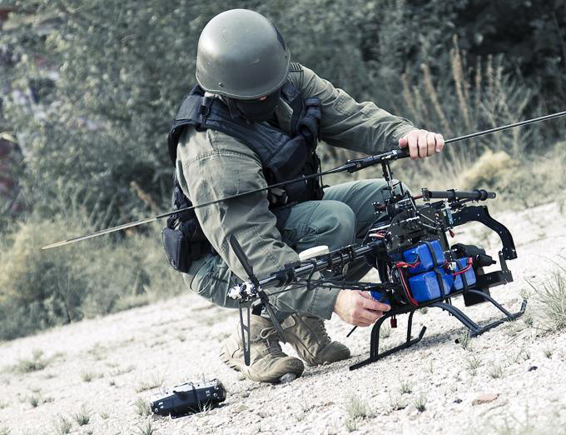Police UAV Drones are used for:

* Tactical Operations
* Fire Investigations & Assessments
* Criminal Pursuit
* Search & Rescue Operations
* Crowd Control
* Emergency Response
* Traffic Investigations
* Forensics
* CBRNE (Chemical, Biological, Radioactive, . Nuclear, Explosives) (PoliceUAVdrones, n.d.)

## Agriculture

Agriculture is predicted to be one of the major industries to incorporate drones in the short term future. Farmers can employ drones to assess crop health with thermal imaging cameras, assess drought conditions and use them to apply insecticides.

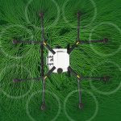DJI, the popular Chinese drone manufacturer, as announced that they are establishing a service network to expand the use of UAV’s in China. The agricultural drone could load 10Kg of pesticides and spray an area up to four hectares per hour. Its work efficiency can reach more than 40 times of a human and will also solve the shortage of works in rural areas. This drone will be based on the MG-1, a farm-specific drone that DJI launched November 2015.

(Schroth, 2016)

## Business & Companies

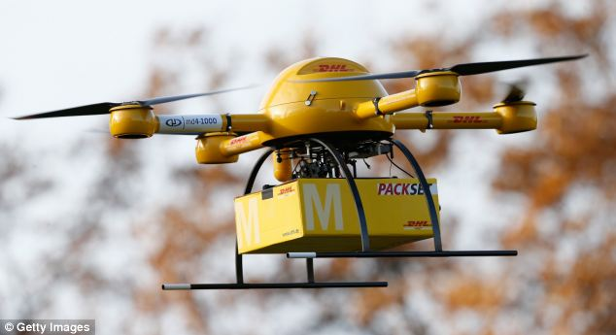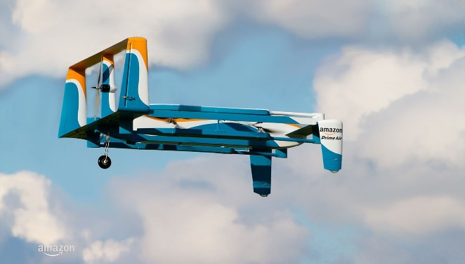Companies seek dominance in their variety of partnerships, alliances and collaborations and in order to stay ahead of the game, modern technology can be used. More specifically, commercial drone technology. With drones being so light, nimble and agile, they make the perfect candidates for delivery robots. For example, companies like Amazon and DHL have been manufacturing and test flying their proto-type delivery drones. (Murphy, 2016)

Furthermore, supermarket retail companies such as Asda have been acquiring drone licenses in order to deliver their shopping via the skies using similar delivery drones. NASA (National Aeronautics & Space Administration) have also been discussing a drone traffic management system with the UK government. It is suggested that civilian drones could be tracked and traced for security and safety reasons. (Murphy, 2016)

## Racing

Drone racing, as previously mentioned is a new trend that is taking the unmanned vehicle racing community by storm. Instead of the usual RC (Radio Controlled) ground vehicle racing, there is now a drone racing league. You can access the website here: ‘www.thedroneracingleague.com’ where you can see the current standings, races types and some cool looking videos filmed on board the drones.

## Filming, Cinematography & Photography

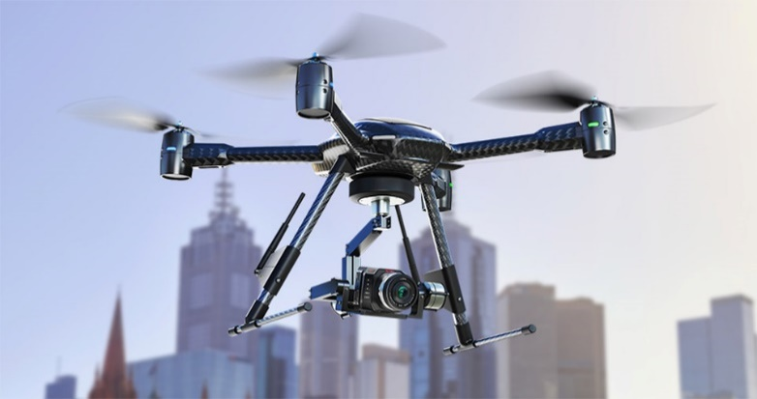One of the main reasons a lot of people purchase drones is to mount a camera to the body and take some awesome aerial photos and videos. Not only that, the drone allows for a whole different angle and style of shooting. It can provide a cheap alternative to cherry pickers and cranes that are normally used to achieve the correct altitude to film. It also allows a full 360 degree filming angle as the drone can smoothly rotate and manoeuvre in the sky.

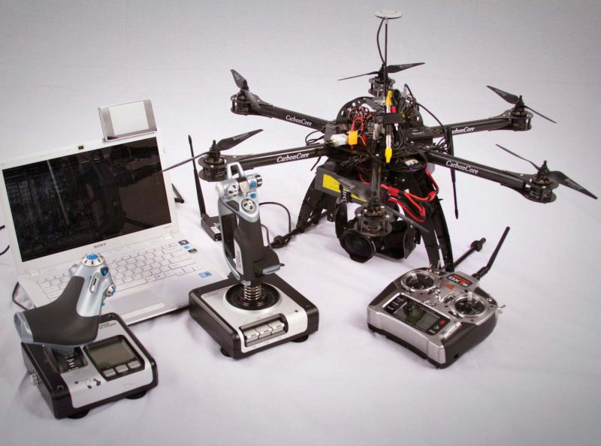

Lots of YouTube video makers and Film/TV cinematographers are starting to reap the benefits of using commercial drones for filming purposes.

# Commercial Drones in Education

Considering the many uses drones have, they can all be applied to the use of learning in an educational environment.

## Further Education (FE):

Drones can be used by engineering students at Further Education as they involve lots of complex components like motors, servers and cameras. Engineering, computer science and media students can team up in order to build a drone, program it, and film great shots using cinematography. This encourages teamwork and utilises all the different skills that everyone has to offer. A class project can be undertaken throughout the year while they are marked both independently and as a group.

## Higher Education (HE):

The same applies for Higher Education. Due to the filming and photography capabilities of drones, they are very useful for producing images and videos for art/media/film students. They can produce footage and images that were impossible before due to student project budgets. They can also be used for computer science and engineering students as they can be manually programmed using a small computer such as a Raspberry Pi. University students have been seen using voice commands to control autonomous drones and programming them to perform specific tasks. There is a drone called the ‘nodecopter’ that uses node.js in order to program the drone. This lets you use any language in order to command the drone to do any action you wish. It can be utilised by programming students in order to practice writing code while working with a drone. (Afshar, 2014) (Anon., n.d.)

# Website Testing in Multiple Browsers

## Google Chrome:

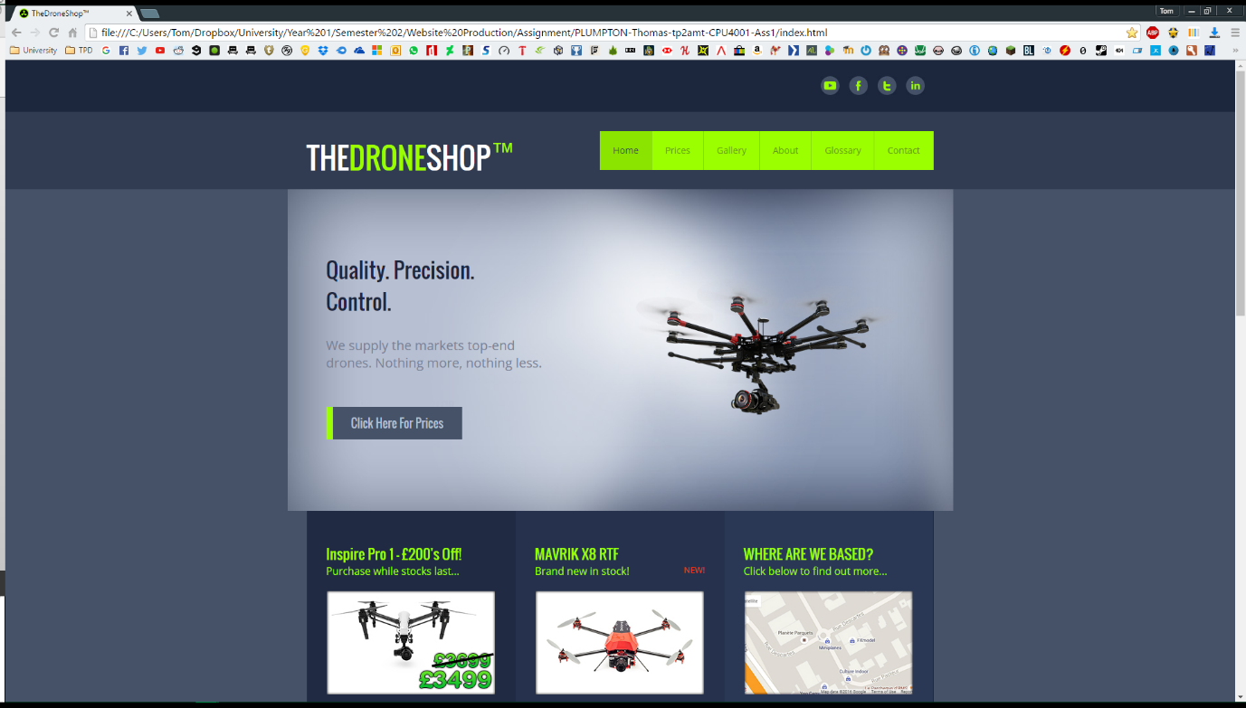

The screenshot above shows TheDroneShopTM loading correctly in Google Chrome. All of the JavaScript & jQuery related elements function correctly. Such as the image rotator on the Home Page and the Image Rollovers in the Gallery. All external page links load in a new tab and the embedded YouTube video plays. There are no formatting issues with the layout of the pages.

## Mozilla Firefox:

The screenshot above shows TheDroneShopTM loading correctly in Mozilla Firefox. As with Chrome, All of the JavaScript & jQuery related elements function correctly. Such as the image rotator on the Home Page and the Image Rollovers in the Gallery. All external page links load in a new tab and the embedded YouTube video plays. There are no formatting issues with the layout of the pages. The page loads just as quickly and smoothly as other browsers.

## Microsoft Edge:

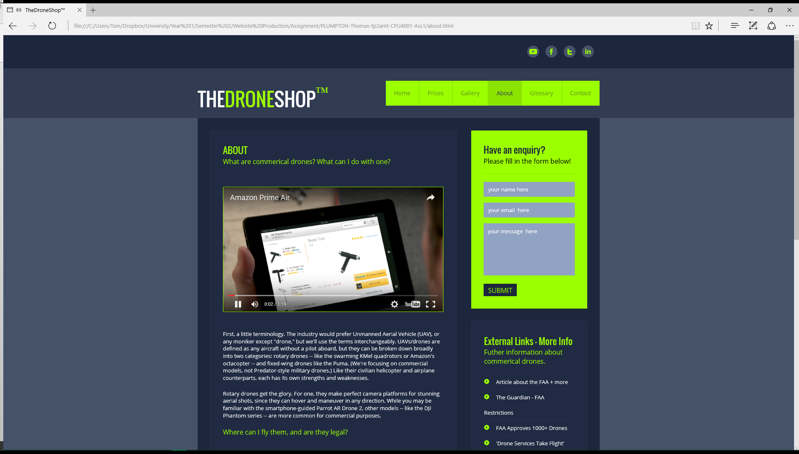

Microsoft Edge seems to be the same as the other browsers performance wise. Again, there are no formatting issues and all of the JavaScript/jQuery elements load and function correctly. The only thing I did notice, which was rather unusual, was the ‘TM – Trademark’ symbol was in the incorrect font (Zoomed in image below).



The same font is used in the ‘THEDRONESHOP’ text just to the left, and in several other instances around the website. The font is drawn from an external link in the HTML <head> section. For some unknown reason, Edge cannot find the font and apply it to the superscript text and has defaulted to another font.

# Web Based Image Editing

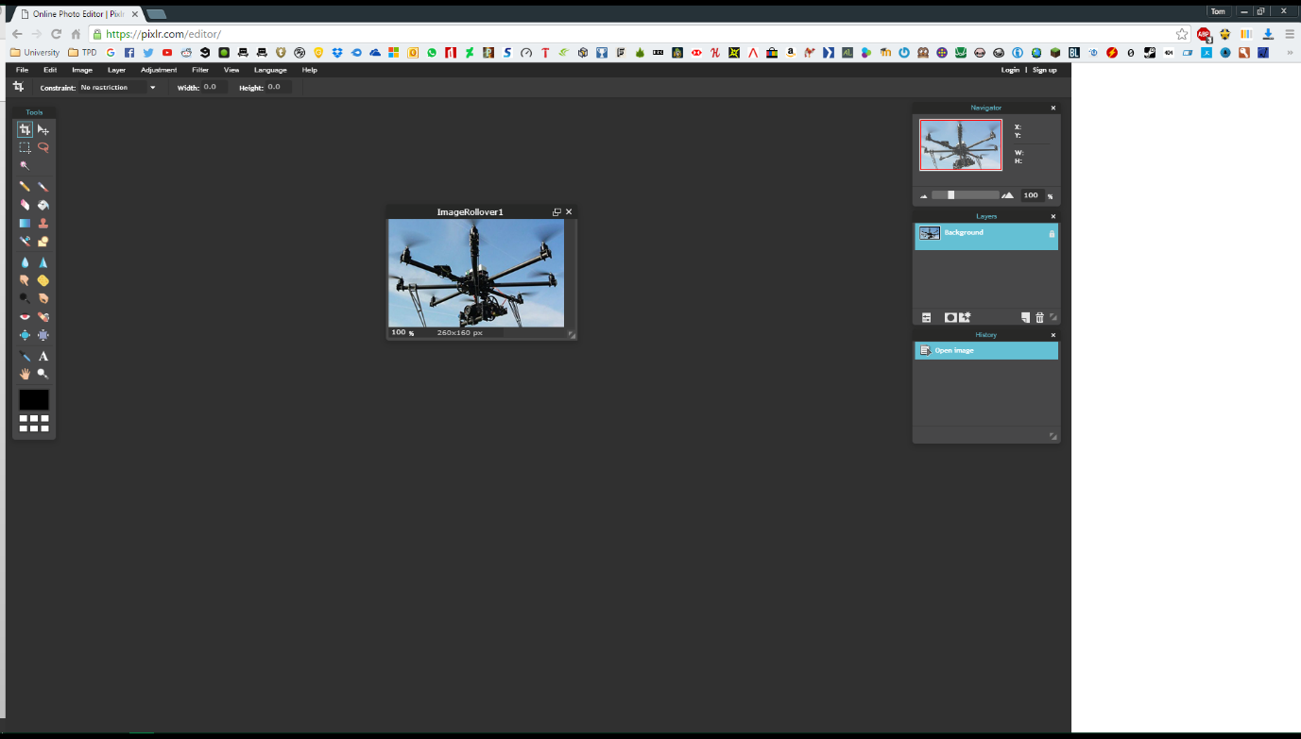



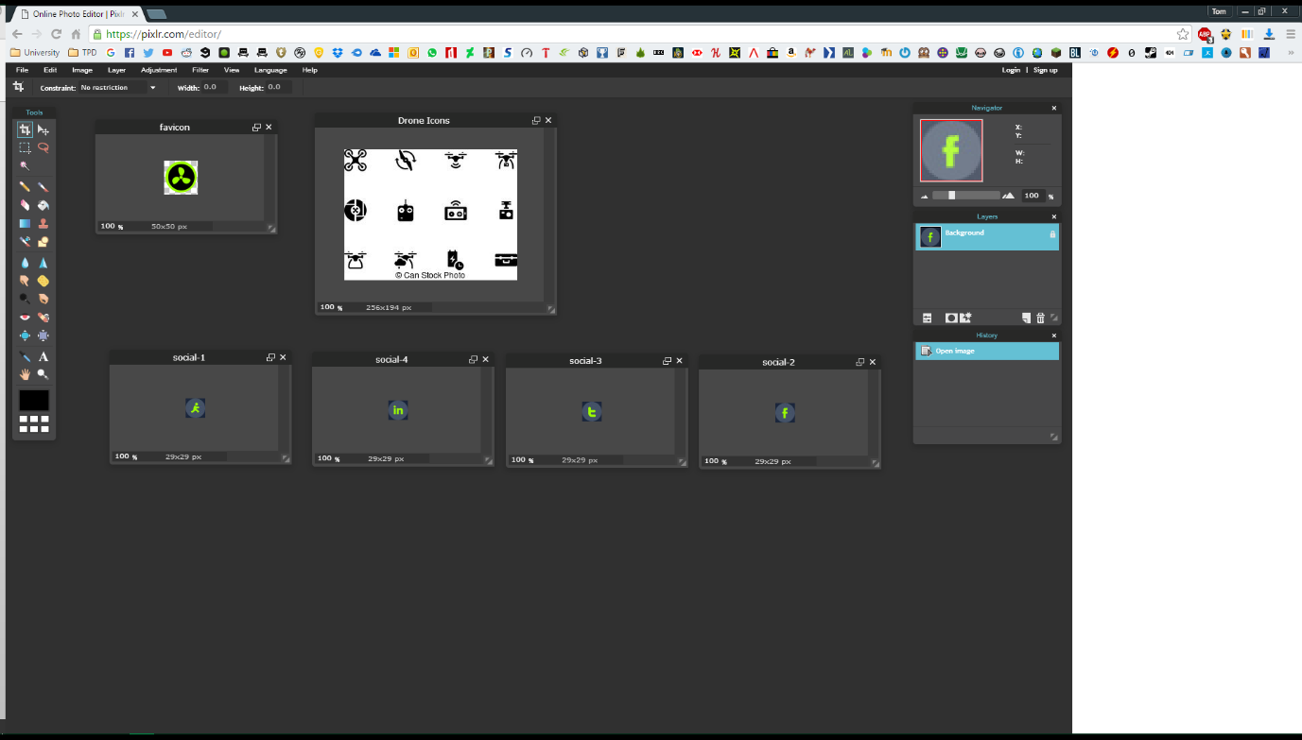In order to edit and re-size the images for use on my site, I used ‘pixlr.com’, a free online image editor. As you can see from the screenshot above, I had to resize certain gallery images to ‘260x160px’ in order from them to fit and align correctly. The same applies for my jQuery and JavaScript carousel.

As you can see from the screenshot above, I also used Pixlr in order to crop out certain parts of images that I needed to be independent. I also re-sized and created some extra social media icons that would be display along the top banner of the website, along with the ‘favicon’ that is displayed on the web browsers tab.

# HTML Validation

*(You may need to zoom in to read the small text. Hold ctrl + scroll mouse wheel)*

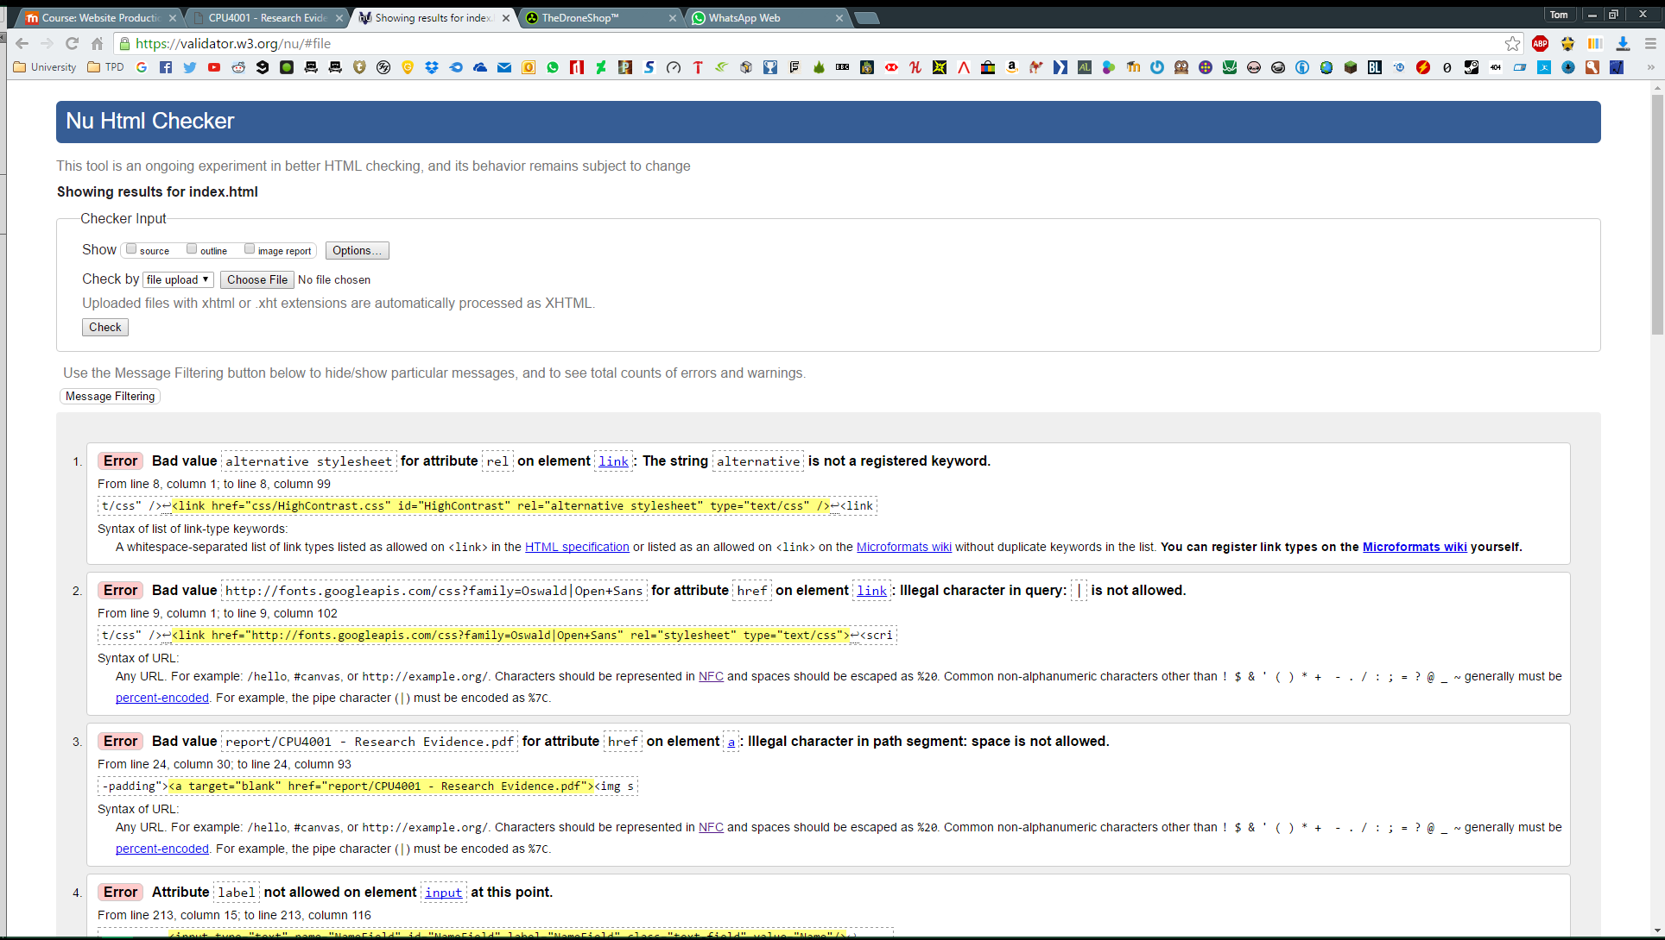**Index.html:**

There are a few errors on my index.html page. One of which is unavoidable. The validator doesn’t allow the ‘|’ character. However, it is part of the URL for the font import. Therefore, without it the URL would be incorrect and the webpage would not be able to locate the font ‘Open Sans’. The ‘alternative stylesheet’ relationship attribute is not recognised, but needs to be different in order to differentiate between the default style sheets and the alternate High Contrast stylesheet. Another error is the white spaces in this reports file name. The button on the website simply links you to this report for ease of use and does not need validating for this assignment.

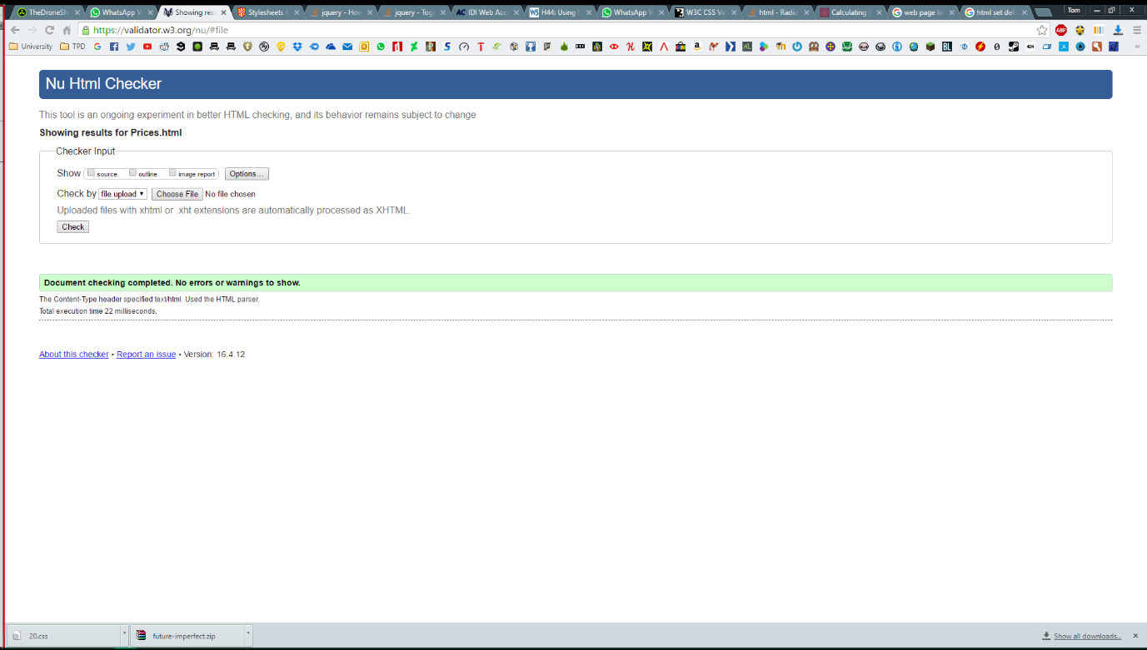**Prices.html**

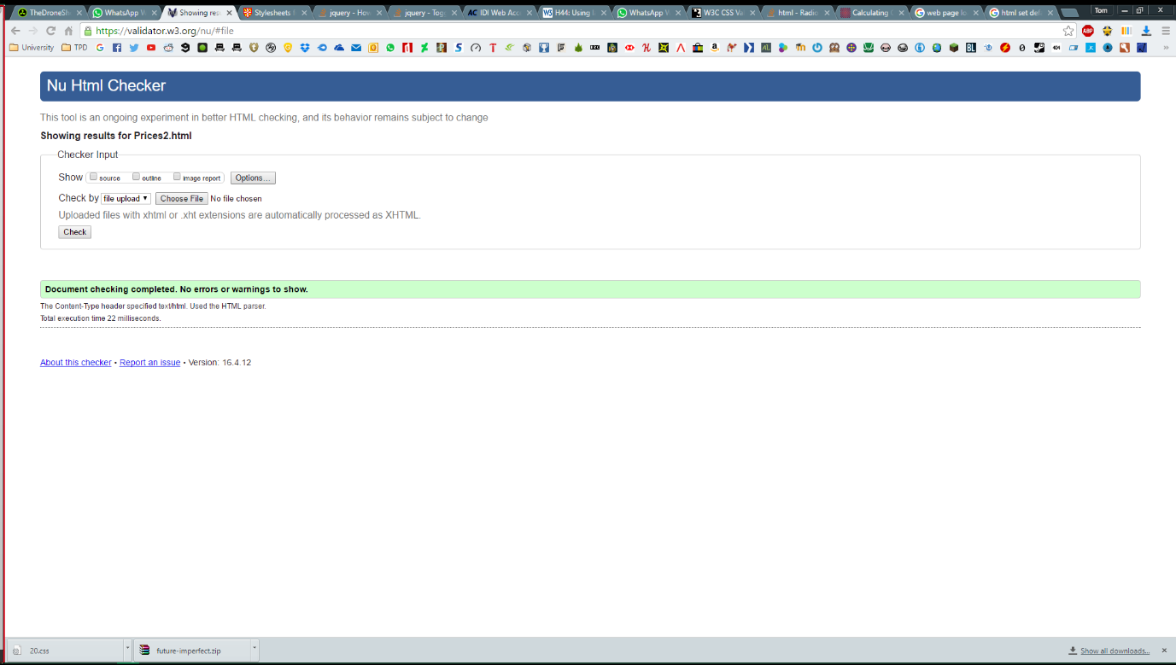**Prices2.html**

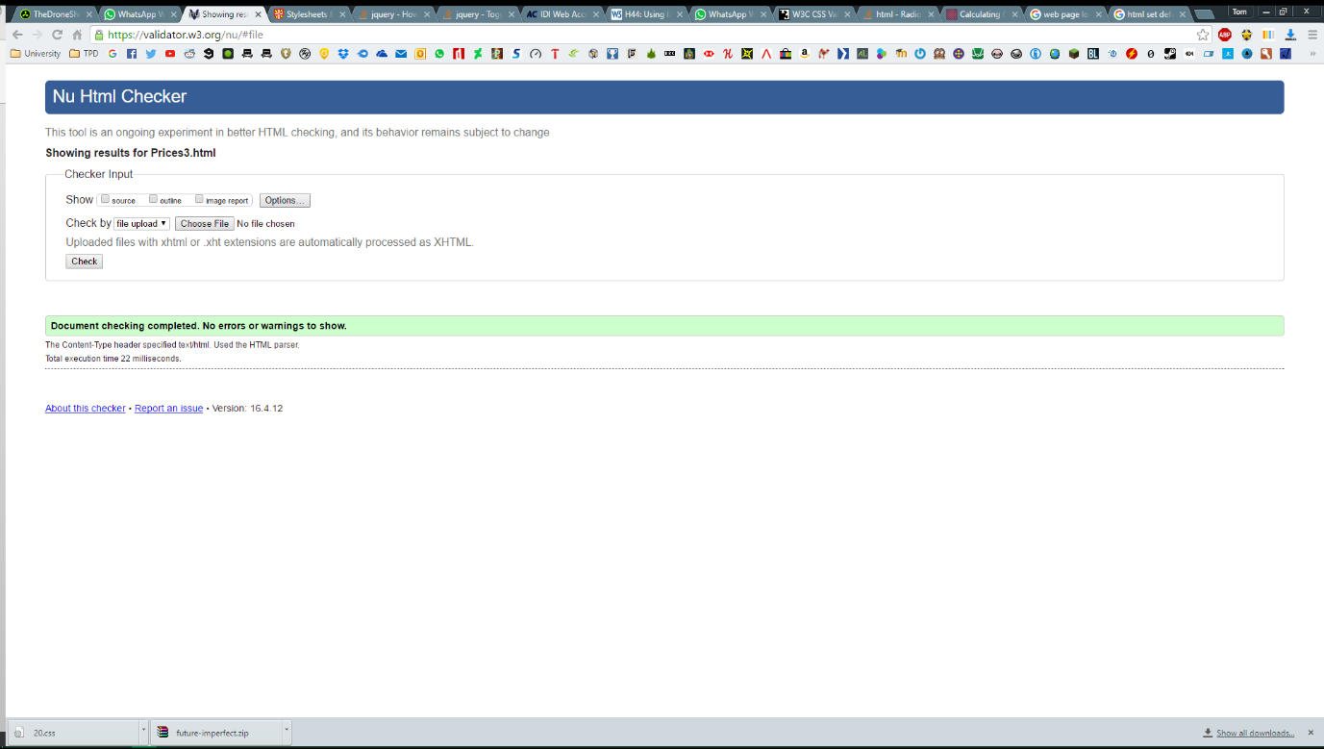**Prices3.html**

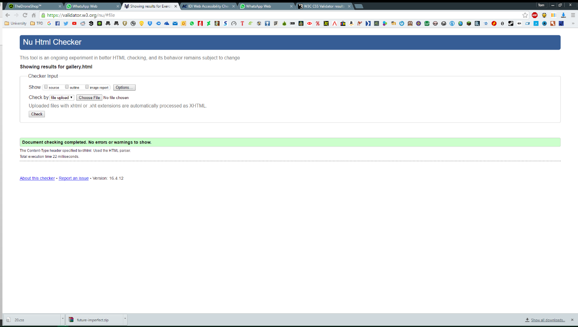**Gallery.html**

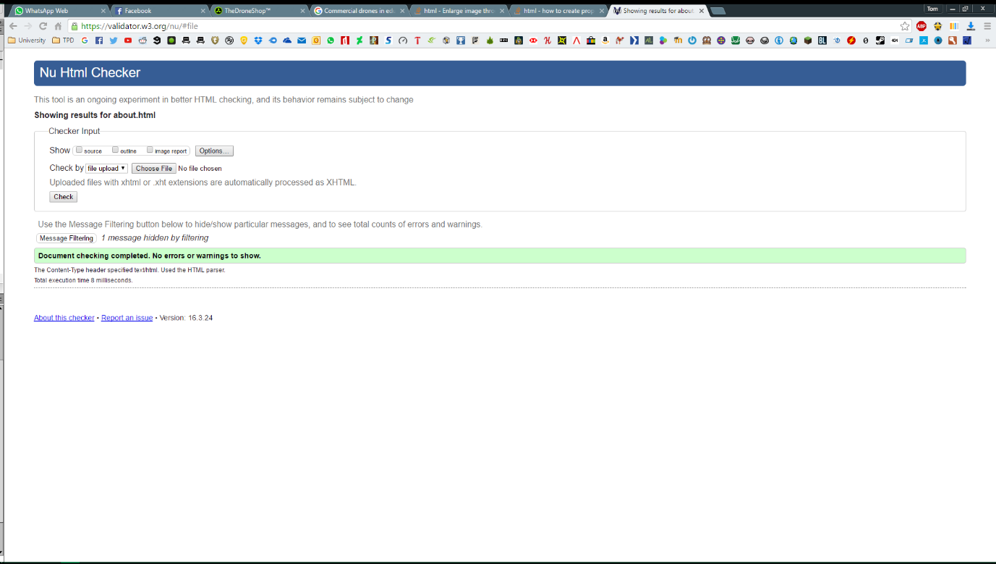**About.html**

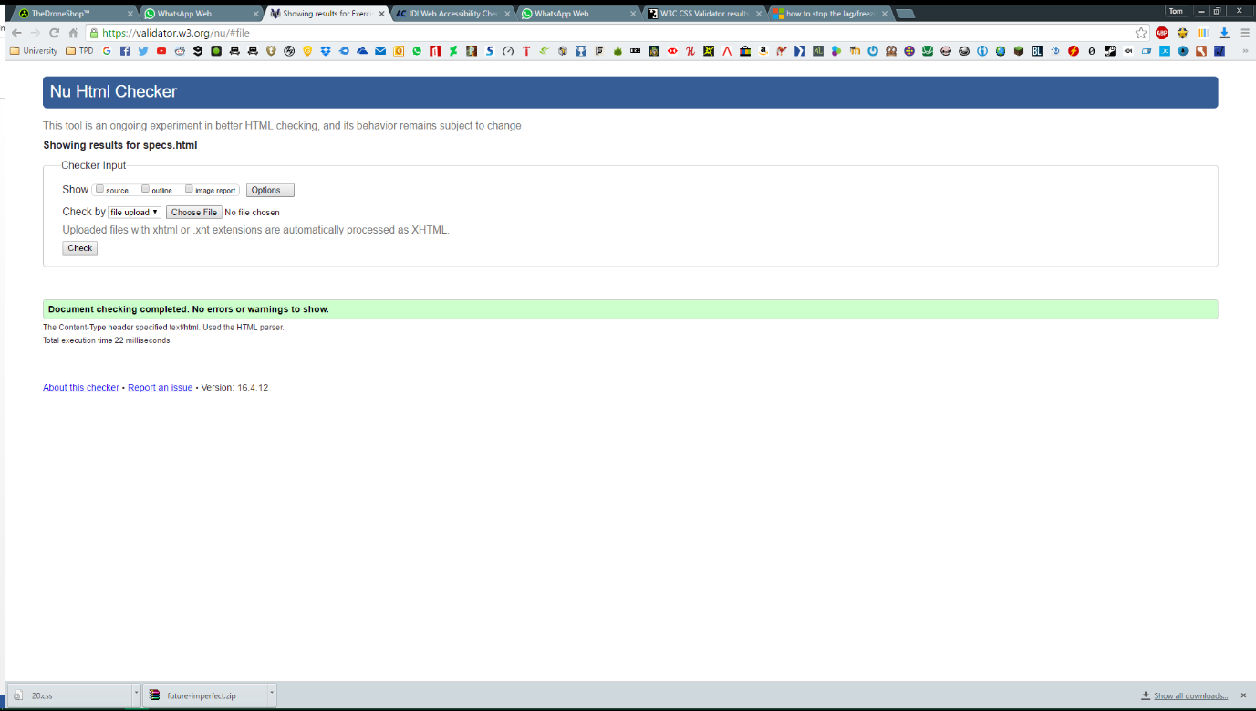**Specs.html**

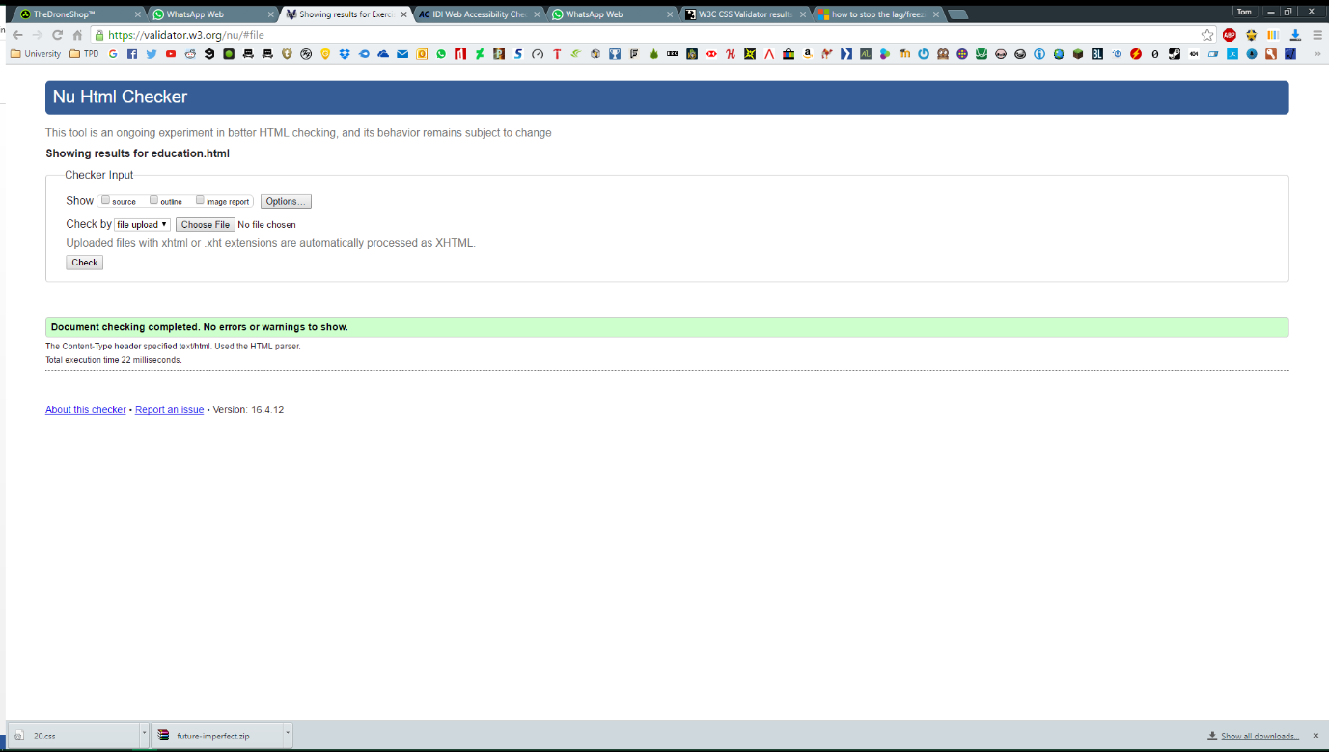**Education.html**

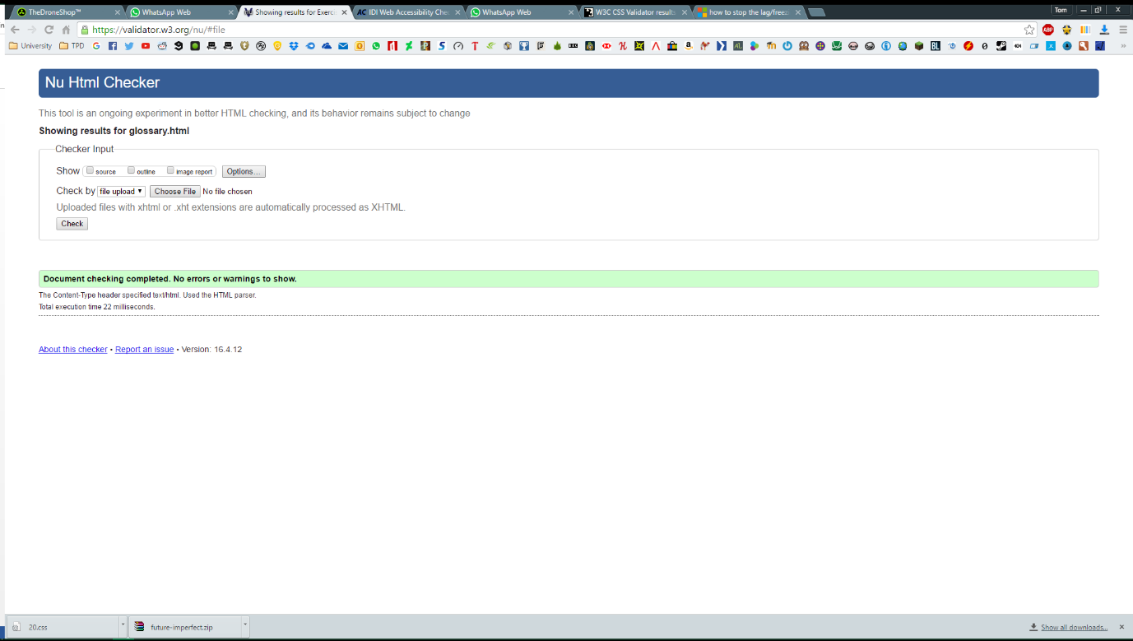**Glossary.html**

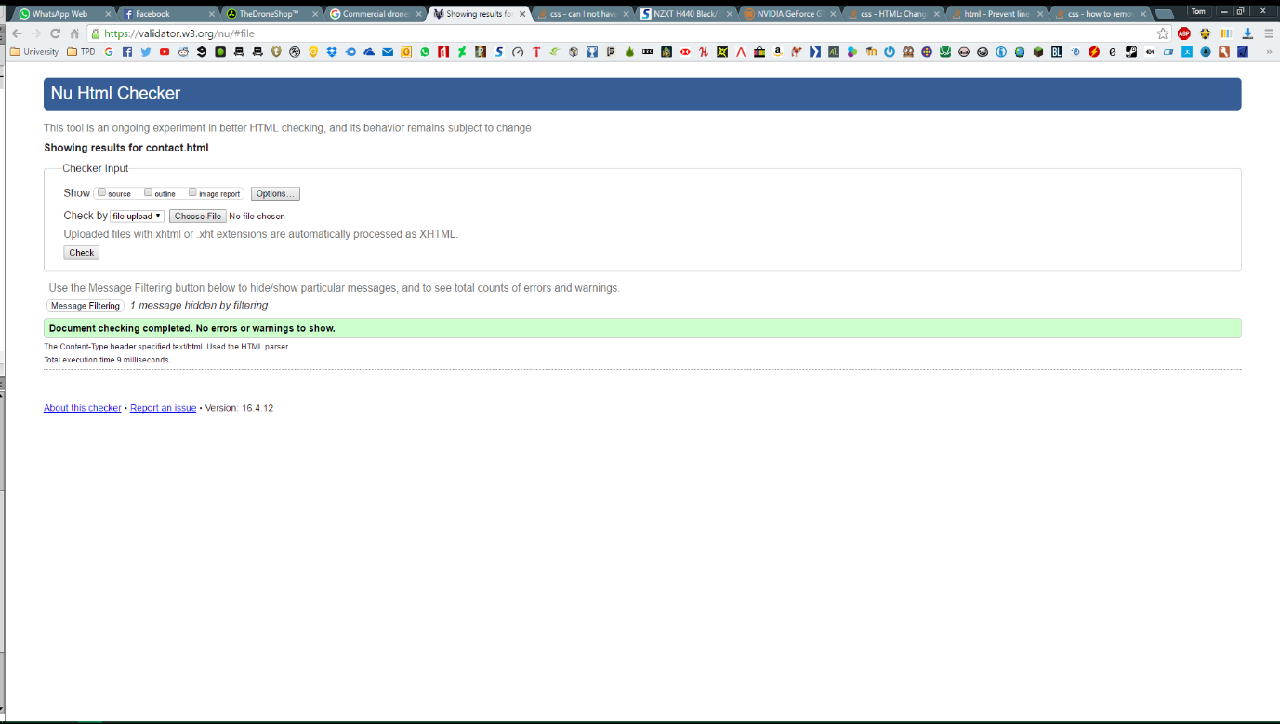**Contact.html**

# CSS Validation

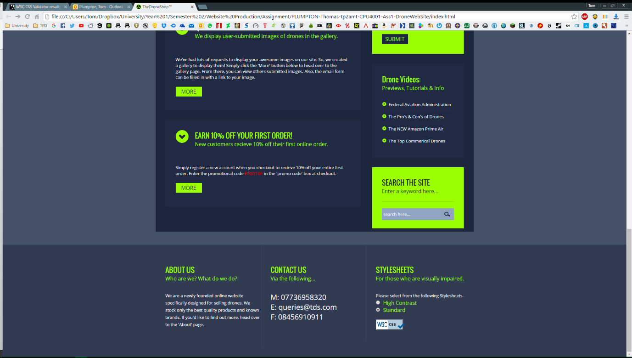After validating my CSS, there were 0 errors. W3C Then provided a code snippet which I could paste into my website and display their logo to prove that it has been verified and is interoperable.

The screenshot above shows the icon on my site.

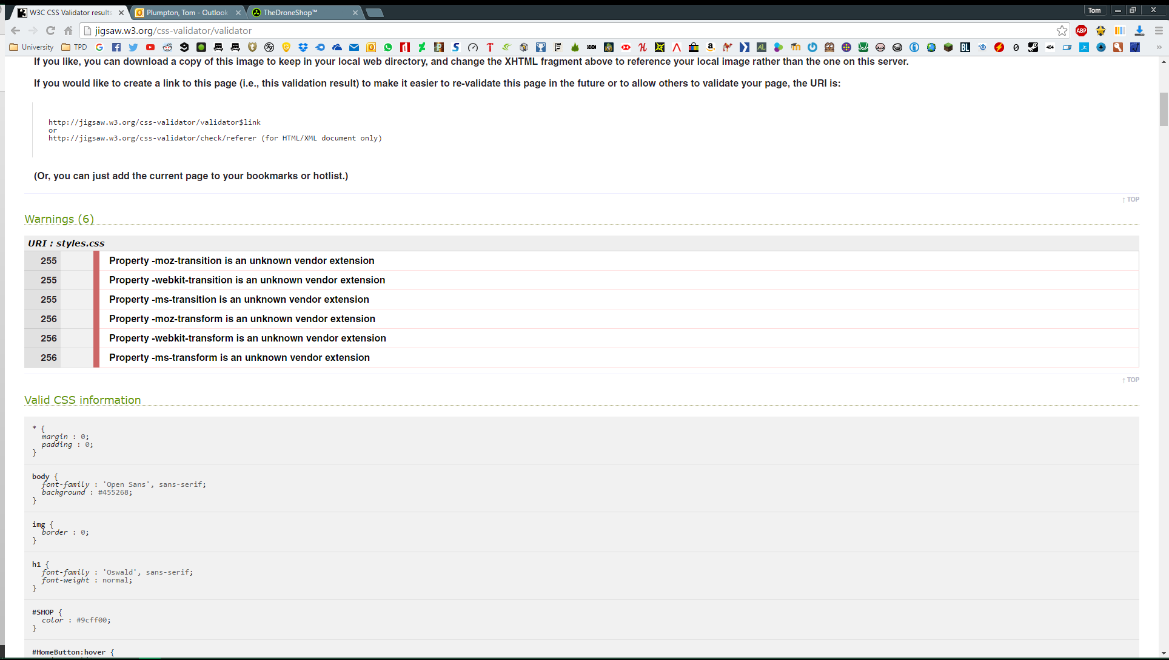There were however, 6 warnings provided by the CSS Validator. These are not an issue as they are simply due to an unknown vendor extension.

# Web Accessibility Validation

The web accessibility validator flagged errors on my forms. The form field themselves had the ‘value’ attribute set to ‘Name’, ‘Email’, ‘Message’ etc… therefore there was no need to add a set of <label></label> tags beforehand. This will result in even further errors and would add another piece of text above the field. This text would be unnecessary and would make the form look cluttered.

# High Contrast Style Sheets

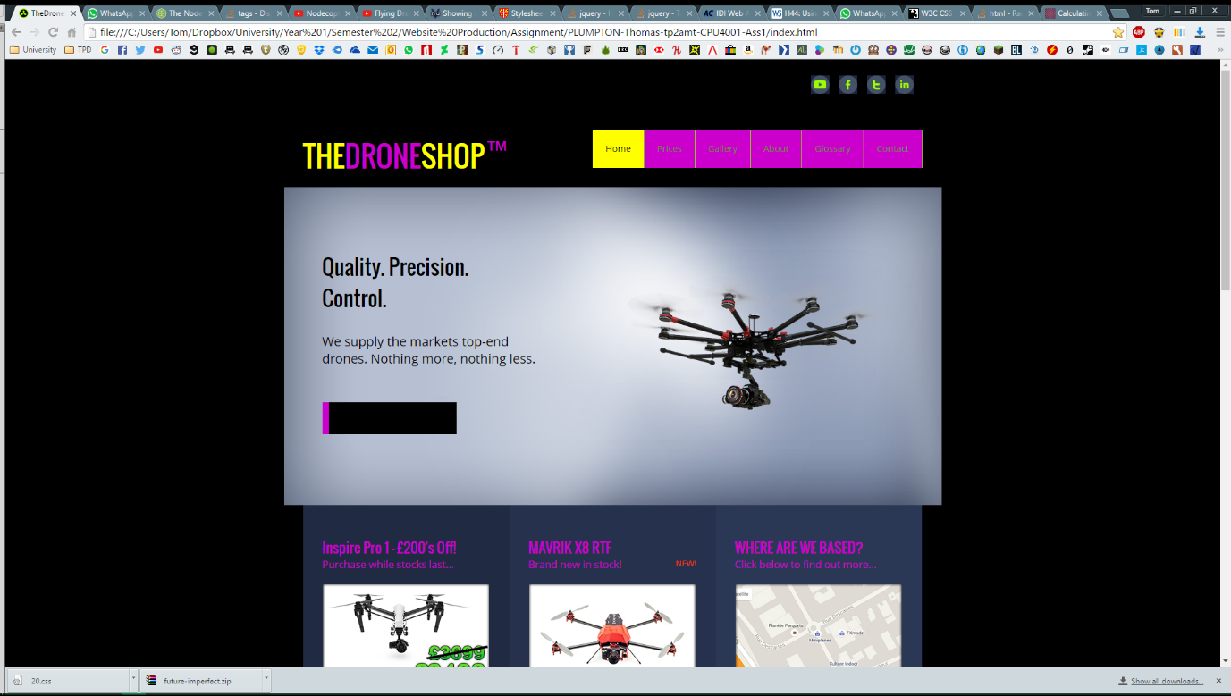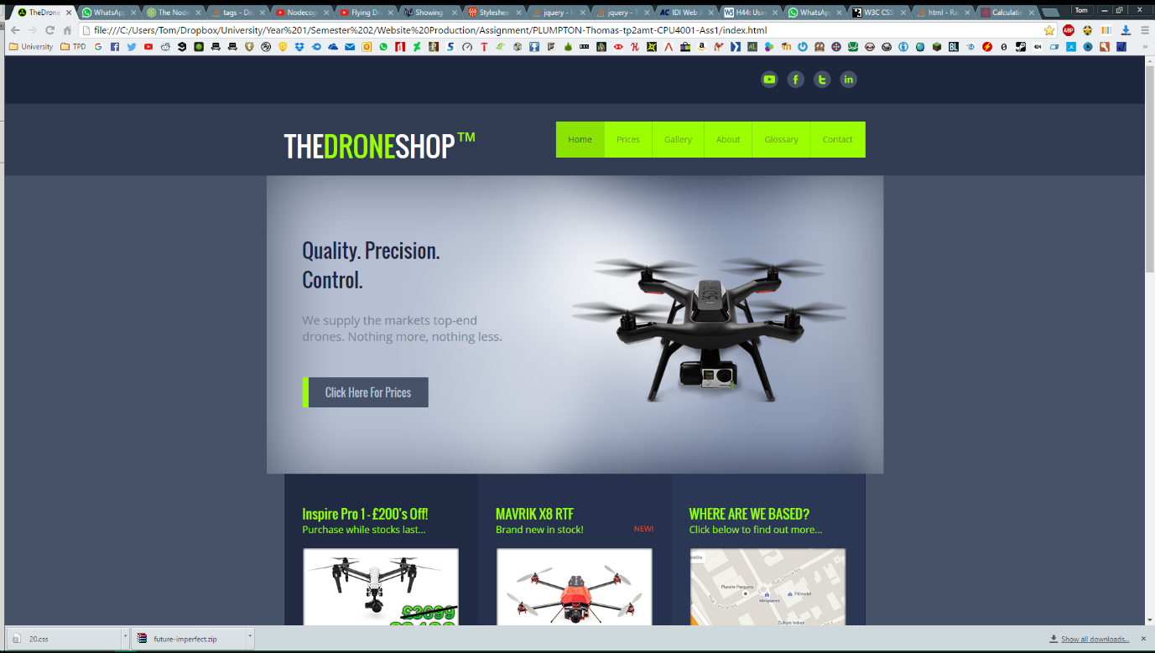

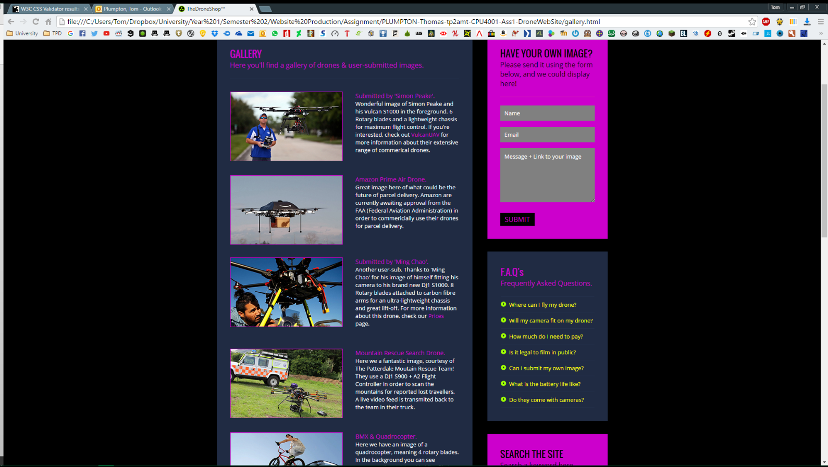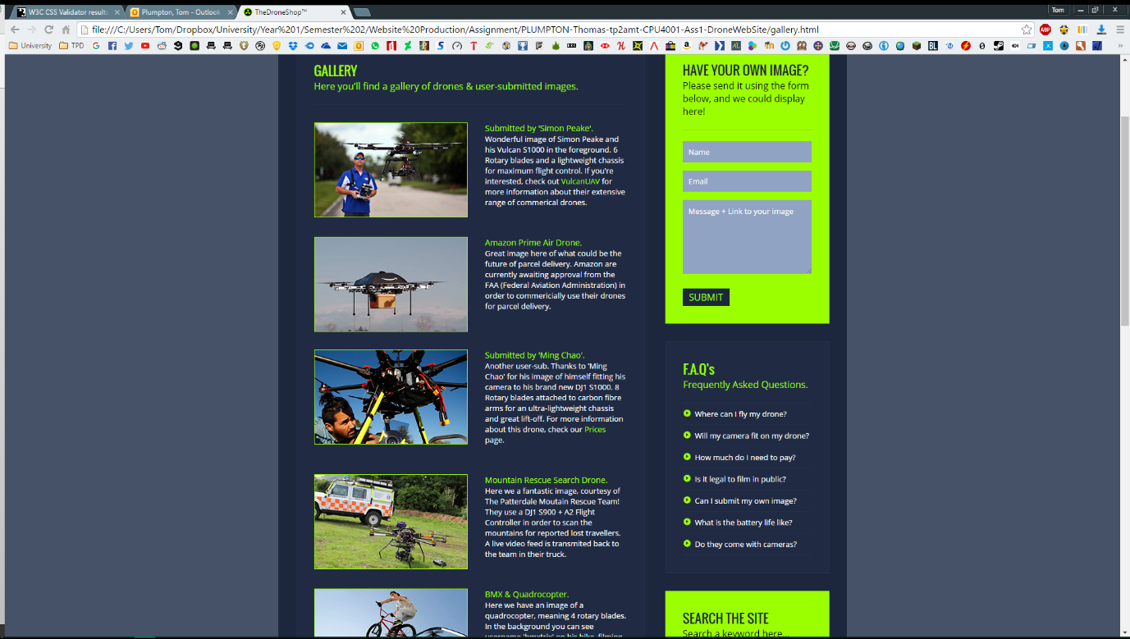

The different style sheets are activated by checking the radio buttons at the bottom right hand corner of the pages footer. ‘Standard’ and ‘High Contrast’ are available.

# References

Afshar, V., 2014. *10 Uses of Drones in Higher Education [Slideshare].* [Online]   
Available at: http://www.huffingtonpost.com/vala-afshar/10-uses-of-drones-in-high_b_5988758.html  
[Accessed 12 04 2016].

Amazon, n.d. [Online]   
Available at: http://g-ecx.images-amazon.com/images/G/01//112715/image-4._CR0,8,1340,762_.jpg  
[Accessed 01 04 2016].

Anon., n.d. *NodeCopter.* [Online]   
Available at: http://www.nodecopter.com/  
[Accessed 13 04 2016].

Anon., n.d. *W3C Web Content Accessibility Guidelines 2.0 Conformance Logos.* [Online]   
Available at: https://www.w3.org/WAI/WCAG2-Conformance.html  
[Accessed 23 03 2016].

AOL, n.d. [Online]   
Available at: http://o.aolcdn.com/hss/storage/midas/b6fc8b5c71468d32a0342c28b3157aa8/201850546/blackmagic-micro-cinema-camera-2015-04-13-02.jpg  
[Accessed 01 04 2016].

Asher, N., n.d. *The Psychology Of Colour In Website Design.* [Online]   
Available at: http://roarlocal.com/the-psychology-of-colour-in-website-design/  
[Accessed 24 03 2016].

Cao, J., 2015. *thenextweb.* [Online]   
Available at: http://cdn1.tnwcdn.com/wp-content/blogs.dir/1/files/2015/04/Real-Color-Wheel-Clean7x7-72dpi.png  
[Accessed 24 03 2016].

Cao, J., 2015. *Web design color theory: how to create the right emotions with color in web design.* [Online]   
Available at: http://thenextweb.com/dd/2015/04/07/how-to-create-the-right-emotions-with-color-in-web-design/#gref  
[Accessed 24 03 2016].

Curtis, S., 2015. *Drone laws in the UK – what are the rules?.* [Online]   
Available at: http://www.telegraph.co.uk/technology/news/11541504/Where-is-the-legal-line-in-flying-drones.html  
[Accessed 25 03 2016].

DroneLife, n.d. *DroneLife.* [Online]   
Available at: http://dronelife.com/drone-safety-and-security/?utm_source=TopMenu&utm_medium=SafetyandSecurity&utm_campaign=SafetyandSecurity  
[Accessed 01 04 2016].

DroneRacingLeague, 2016. *TheDroneRacingLeague.* [Online]   
Available at: http://thedroneracingleague.com/  
[Accessed 24 03 2016].

GettyImages, n.d. [Online]   
Available at: http://i.dailymail.co.uk/i/pix/2013/12/09/article-2520818-19FB489500000578-0_634x345.jpg  
[Accessed 01 04 2016].

Henry, S. L. & Dick, W., 2005. *Introduction to Web Accessibility.* [Online]   
Available at: https://www.w3.org/WAI/intro/accessibility.php  
[Accessed 23 03 2016].

Henry, S. L. & Dick, W., 2011. *WCAG 2 at a Glance.* [Online]   
Available at: https://www.w3.org/WAI/WCAG20/glance/  
[Accessed 23 03 2016].

Murphy, M., 2016. *15 UK companies using drones.* [Online]   
Available at: http://www.techworld.com/picture-gallery/personal-tech/6-best-uses-of-drones-in-business-3605145/#5  
[Accessed 01 04 2016].

PoliceUAVdrones, n.d. *policeuavdrones.* [Online]   
Available at: http://www.policeuavdrones.com/  
[Accessed 01 04 2016].

Schroth, F., 2016. *DJI Establishing Agricultural Drone Service Network in China.* [Online]   
Available at: http://dronelife.com/2016/03/22/dji-expanding-agricultural-drones-in-china/  
[Accessed 01 04 2016].

Solmecke, R. C., 2014. *Civilian drones and the legal issues surrounding their use.* [Online]   
Available at: https://www.wbs-law.de/internetrecht/civilian-drones-legal-issues-surrounding-use-50459/  
[Accessed 25 03 2016].

Specout, n.d. *specout.* [Online]   
Available at: http://drones.specout.com/  
[Accessed 24 03 2016].

# Appendices

Appendix 1: Colour Wheel (Cao, 2015)

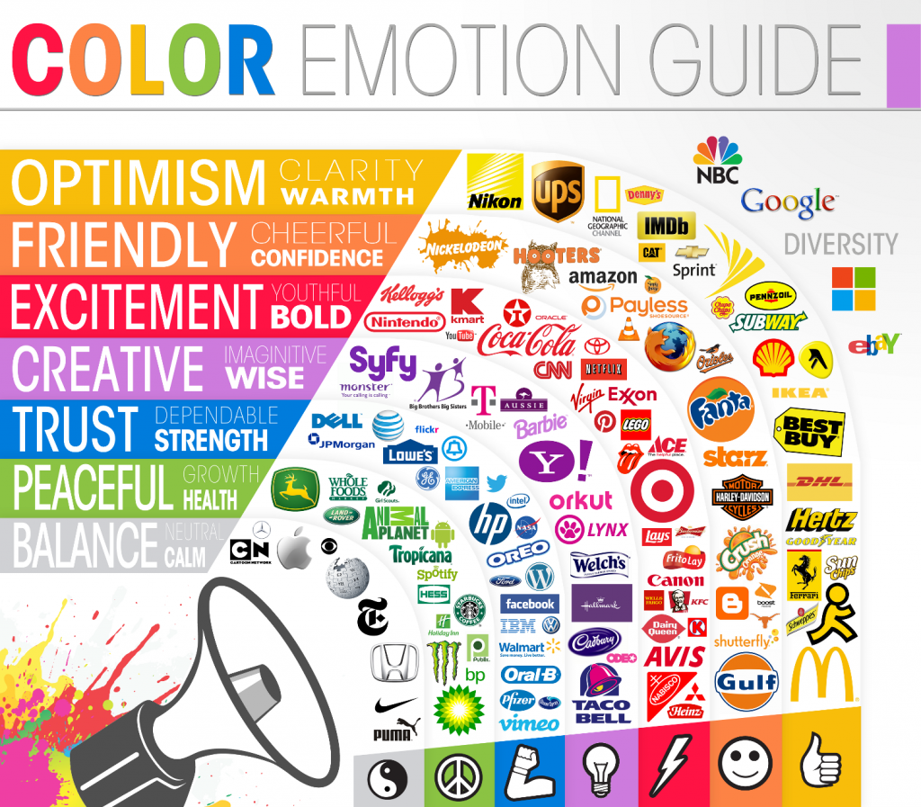Appendix 2: Colour Emotion Guide (Asher, n.d.)